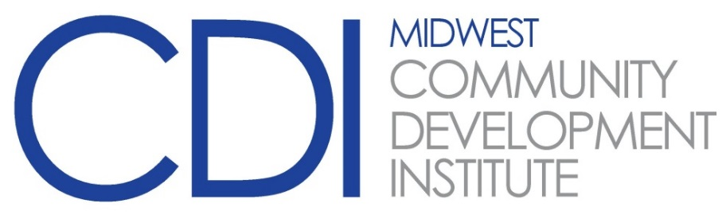

2022 Advanced Year
Alumni Gathering (Year 3 completers)
Tuesday, August 9 – Wednesday, August 10
Stoney Creek Inn, Moline, IL

Tuesday, August 9, 2022

9:30 – 10:00 am Registration

10:00 – 10:15 am Greetings and Introductions

10:15 – 11:45 am “Diversity, Equity, and Inclusion”
Lisa Bly-Jones, Chicago Jobs Council

11:45 – 1:00 pm Lunch

1:00 – 2:15 Workforce Development Workshop

2:15 – 2:35 pm Break

2:35 – 3:45 pm Workforce Development Workshop (continued)
3:45 – 5:00 pm Economic Development in Mattoon
Carlos Ortega, Elevate CCIC, Inc.
5:30– 6:30 pm Optional PCED Review

Wednesday, August 10, 2022

8:30 – 8:45 am Greetings & Announcements

8:45 – 10:00 am “Marketing Your Hometown”
Cole McDaniel, Spoon River Partnership for Economic Development
Amanda Woodruff, Spoon River Partnership for Economic Development
Carla Bobell, Chamber of Commerce, Canton, Illinois

10:00 – 10:30 noon Break

10:30 – 11:45 am TBA
11:45 – 1:00 pm Lunch

1:00 – 4:00 pm “Community Digital Marketing , What's Working in 2022”
Andrew Skattebo, Brickstreet Digital

